TMT/+918762926950/S0690/2024 02-03-2026

To,
Channa basav
Mobile: +918762926950

Dear sir,

Sub :- Your Requirement of Slitting Line – 500 mm Wide Thickness 13 mm

Thank you very much for your enquiry regarding your requirement of slitting machine mainly for HR Sheets. We are glad to inform you that we would be in a position to supply you the required equipment. Given below are the required specifications and description of the machine and our terms and conditions.

S No | Description of the unit | Offer
1. | Slitting machine along with un-coiler, Leveler Unit, Entry guide, shearing unit, slitter head, scrap winders – 2 No’s, coiler, separator and over arm units, delivery coil cars, along with power pack and other electrical connections Without cutters and Spacers | 19,00,000/- (Rupees Nineteen Lakhs Only)

LIST OF EQUIPMENTS
- Un-coiler – Hydraulic
- Pinch roll cum leveler
- Entry Shear
- Vertical entry guide
- Tensioner pad
- Slitter Assembly
- Scrap winder -2 Nos.
- Loop pit with loop control
- Pinch roll
- Re-coiler with over arm separator
- Turnstile
- Hydraulics
- Electrical
TECHNICAL SPECIFICATION:

GENERAL DATA

Productivity : MAKING WIDE COIL TO SLIT COILS

Manpower required : ONE OPERATOR TWO ASST. REQUIRED

Total Power Required : 510 HP

Set up time : COIL LOADING 12-15 MIN, SHEET FEEDING 3-4 MIN

Production capacity : 100000 KG PER SHIFT 8 HOURS

Working hours per day : 24 Hours

Line direction : LEFT TO RIGHT

Overall floor space required : 25 METERS (L) 7 METERS (W) 5 METERS (H)

Approx weight : 125,000 KG

Line speed : 8-30 MPM

Model No : TM/RF/113

Model Type : CRFM

MATERIAL SPECIFICATIONS

Type of material to be processed : CR/MS/HR

uts : 32-42 KG/MM2
% Elongation : 18-25
Shear strength : 40-45 KG/MM2

Maximum width can be processed : 2000 MM

Minimum width can be processed : 550 MM

Maximum thickness can be processed : 12 MM

Mnimum thickness can be processed : 4 MM

ENTRY COIL SPECIFICATIONS

Maximum weight of coil : 35 TON

Maximum od of coil at entry : 1800 MM

Minimum od of coil at entry : 800 MM

DE COILER SPECIFICATIONS

Model : DOUBLE ARM

Load - capacity : 35000 KG MAX.

width : 1250MM

Mandrel movement : DIA 650 MM - 850 MM

Mandrel Height from ground : 1100 MM

Mandrel expansion : HYDRAULIC

Construction : M. S. FABRICATED.

DESCRIPTION OF THE EQUIPMENTS

COILER

The main base of the equipment is MS fabricated body. The drive to the equipment is by means of 300 HP AC Motor along with AC Drive panel, Gear Box system and the mandrel is the extension of the output shaft of the gearbox. The mandrel can be expandable and collapsible with hydraulic actuator. The over arm unit along with separator plates is operated with pneumatic operation the pressure can be adjusted manually. The pusher plate is operated with hydraulic movement for removing the coil after winding. The coil car carries the removed coils from the mandrel, which also moved with hydraulic system.

SLITTER HEAD

The slitter Head consists of 60 HP AC motor along with AC Drive, gearbox system along with Dog clutch and spindle attachment. The arbors vertical distance can be adjusted by means of spur gears train and reduction gearbox attachment. The operator side stand movement is by means of hydraulic cylinder. The de-burring unit is attached after the cutters which is drive free and the load can be given with manual screw adjustment. Scrap winders are with two 10 HP AC -2 motors along with mechanical oil brake clutch system.

ENTRY GUIDE

The entry side of slitter head is by means of guide table; guide blocks along with guide rolls. This will be responsible for centering the leading ends of the sheet in to the first pass.

LEVER AND PINCHROLL

Number of rollers for leveling : 5 Nos

Number of pinch rollers : 2 Nos

Diameter of the roll : dia 120 mm

Load arrangement for leveler : combination gear box

Load arrangement for Pinch roll : hydraulic

Drive : 30 HP AC

The lever is with triangular roll attachment along with combination screw down gearbox with manual wheel movement for adjusting the loads. The pinch roll is allowed the strip to move to forward to entry guides.

HYDRAULIC SHEAR

Hydraulic shear is incorporated after the cutting unit, the main purpose of shearing unit is trimming the entry edges of the strip. The hydraulic shear can able to cut the maximum width is 1600 MM and the thickness of MS Sheet is 6 MM.

HYDRAULIC UNIT

The centralized power pack is of 50 HP-2 AC motor and total distribution piping are in underground trenches.

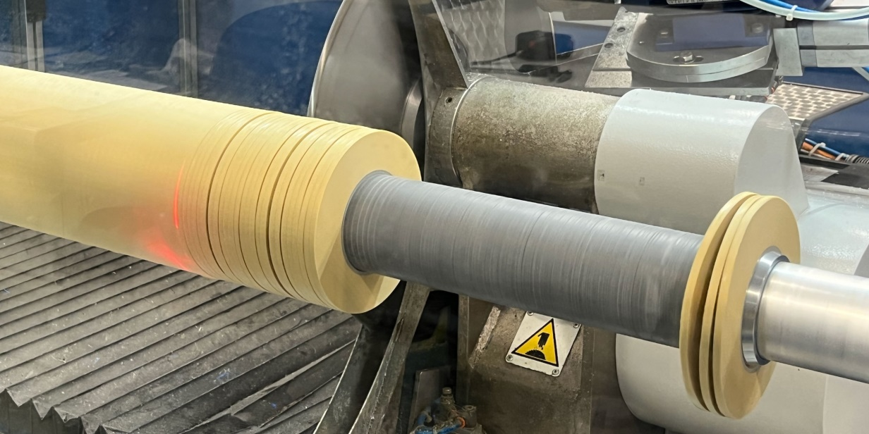

Cutter head with spacers

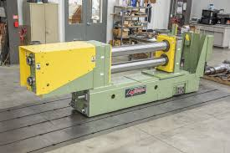

Cutter head assembly
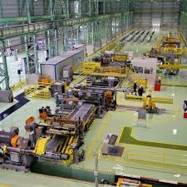

Plant complete view

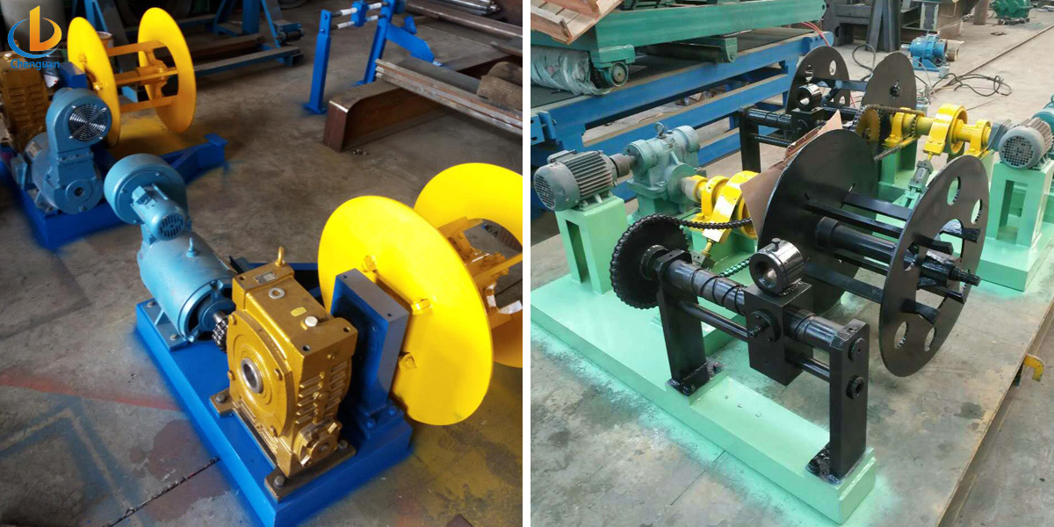
Scrap winders
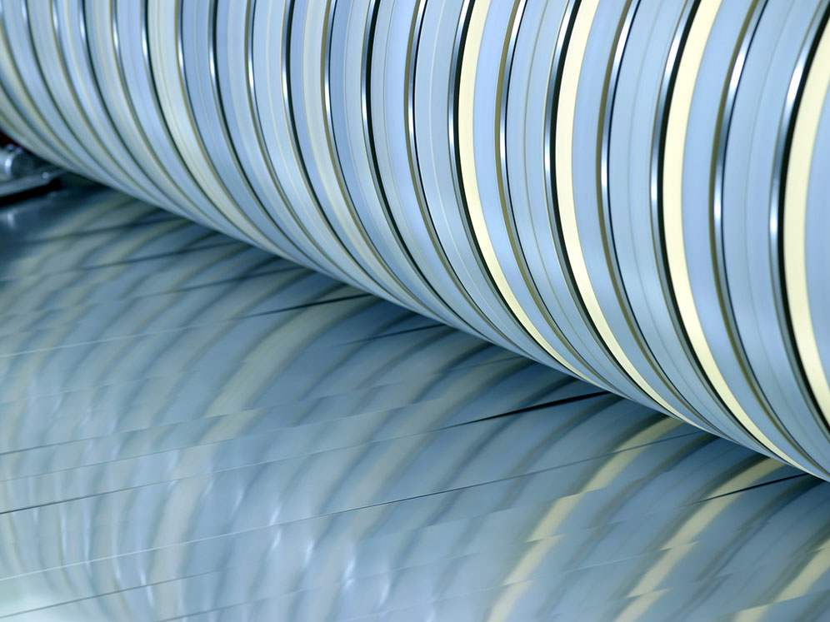
Cutter assembly with spacers and cutters
GENERAL TERMS & CONDITIONS:
- Price quoted per unit : ex-works. Hyderabad.
- Following charges are additional to your account.
- Freight Charge : As actual to be borne by you.
- Packing charge : As actual to be borne by you.
- Sales Tax : GST 18% EXTRA
- Insurance : As actual to be borne by you.
- Payment : 50% advance along with order 20% after 1 month 20% after 2nd month, 5% at the time of delivery and balance 5% after commissioning.
- Delivery : within 4 months
- Validity : One month from the date of submission.
- Inspection : Inspection at our works prior to dispatch.
- Warranty : 12 months from the date of dispatch against any manufacturing defects/ faulty material or bad workmanship of any part or component but not against any kind of abnormal or improper use of machine. Defective part or component will be replaced or repaired free of cost. Electrical components are outside the scope of this warranty.
- Commissioning : Erection & commissioning done by us with extra cost mutually agreed by mutually, but civil works are not in our scope. You have to provide required manpower, lifting arrangement boarding and lodging for our technical people.
NOTE:
- Oil is not in scope of our supply.
- Raw material for trial is to be arranged by you at your cost.

We hope our offer is to your expectation and meet your requirement. Please contact t.sivaramakrishna, (Mob: 9246221106/9849207176)
E- Mail: techno9246221106@gmail.com further information / clarifications required if any.

Thanking you and assuring you of our best services always.

For TECHNO MACHINE TOOLS

( T. SIVARAMAKRISHNA)

